Canopia process and research agents
Canopia turns a voluntary guest conversation into practical briefs for hotel teams. Hotel DNA describes the hotel's identity, services, resources and limits, helping Canopia develop feasible actions.

Option 1 Context enrichment
Refine an existing idea with a relevant detail about the guest, before generating the briefs.
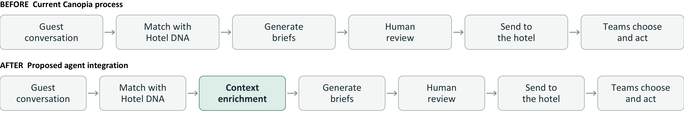

Examples of what changes
Before in the brief | Extra information found | After in the brief
Suggest a run around the hotel. | A reliably identified public running profile shows several recent flat runs of 8 to 10 km. | Suggest an approximately 8 km loop suited to that running pattern.
Choose a book from the hotel library. | A public reading list linked to the guest suggests an interest in Nordic crime fiction. | Suggest a matching title from the hotel's available collection.
Suggest a photography walk. | A public portfolio linked to the guest focuses on architecture and building details. | Focus the walk on architectural subjects and suitable viewpoints.
Each example starts with an interest already mentioned by the guest. Use reliably matched, accessible public sources and show uncertainty. If no useful detail is found, keep the original idea.
Examples are illustrative. The added agent is a proposed hackathon capability.

Option 2 Local experience discovery
Find real local options for the stay and combine them with hotel services into packs that reception or concierge can organise and book. Research happens before the briefs are created.
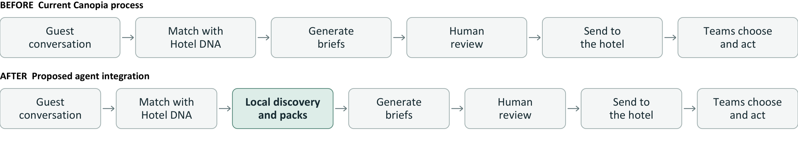

What goes into the search
Guest interests and constraints + Hotel DNA + destination + stay dates. Each pack connects an external activity with relevant hotel services, where those services are present in the DNA.

Examples of what changes
Before in the brief | Local information to find | After in the brief
A couple enjoys photography and a relaxed pace. Suggest a cultural outing. | A photography exhibition open during the stay: theme, opening times, tickets, location and travel time. | A dated exhibition visit, hotel transport and an aperitif on return, with a booking link and a practical schedule.
A guest enjoys live jazz and good food. Suggest an evening out. | A jazz concert on a stay date: programme, start time, venue, ticket price and booking route. | An early hotel dinner, the concert and return transport, with timings that work together.
The brief includes the source, activity, date and time, location, booking route, advertised price and hotel additions. Unchecked availability or missing details stay visible. Research does not make a booking.

Both agents can contribute to the same brief
One, both or neither may be used. Bring their contributions together before generating the briefs, then review and send them. Hotel teams choose what they can carry out; no hotel approval or guest preselection step is built into this flow.
Examples are illustrative. The added agent is a proposed hackathon capability.

